USED CAR PRICES DECREASED OVER THE QUARTER
The Marketing Agency NAPI (National Industrial Information Agency) has analyzed the used car average price dynamics in the period from Q III 2021 to Q III 2022. Prices for premium cars and cars of other price segments (low-cost and medium) have been analyzed. During the year, the average prices for used premium cars aged over 10 years have increased the most (+41.6%), non-premium cars aged 7-10 years have appreciated the least (+12.2%). It should be noted that in Q III prices were adjusted on Q II 2022. Average prices in all the age and price segments under consideration decreased in Q III, except those for premium cars aged over 10 years. These cars appreciated by 1.9% on average over the quarter.
Average prices for used cars aged under 3 years, rubles
Price segments | Q III 2021 | Q IV 2021 | Q I 2022 | Q II 2022 | Q III2022 | Dynamics  Q III 2022/  Q III 2021 | Dynamics  Q III 2022/  Q II 2022
Premium | 5 736 596 | 5 932 861 | 7 629 372 | 8 355 866 | 6 867 558 | 19.7% | -17.8%
Other | 2 084 842 | 2 139 518 | 2 617 727 | 2 814 300 | 2 562 153 | 22.9% | -9.0%

Source: NAPI (National Industrial Information Agency)
Average prices for used cars aged under 3 years, rubles
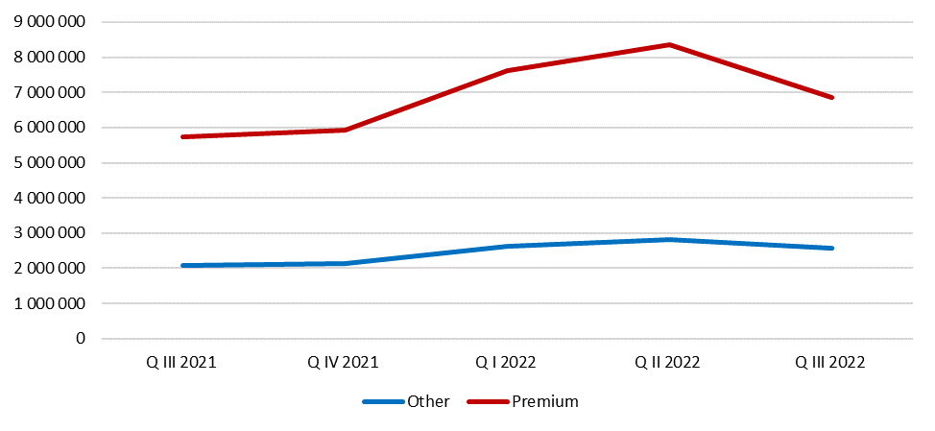
Source: NAPI (National Industrial Information Agency)
Average prices for used cars aged 4-6 years, rubles
Price segments | Q III 2021 | Q IV 2021 | Q I 2022 | Q II 2022 | Q III 2022 | Dynamics  Q III 2022/  Q III 2021 | Dynamics  Q III 2022/  Q II 2022
Premium | 3 271 017 | 3 335 613 | 4 449 528 | 4 277 348 | 3 832 338 | 17.2% | -10.4%
Other | 1 256 029 | 1 304 020 | 1 548 491 | 1 572 838 | 1 482 308 | 18.0% | -5.8%

Source: NAPI (National Industrial Information Agency)

Average prices for used cars aged 4-6 years, rubles
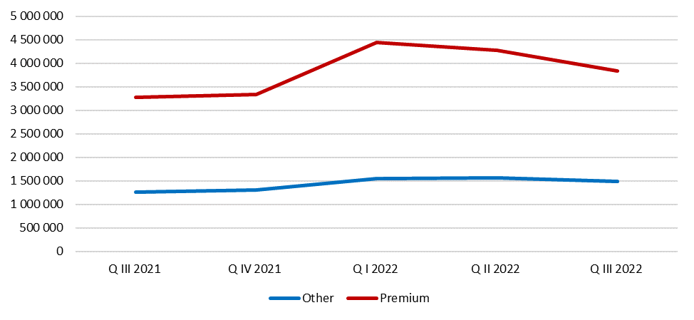
Source: NAPI (National Industrial Information Agency)
Average prices for used cars aged 7-10 years, rubles
Price segments | Q III 2021 | Q IV 2021 | Q I 2022 | Q II 2022 | Q III 2022 | Dynamics  Q III 2022/  Q III 2021 | Dynamics  Q III 2022/  Q II 2022
Premium | 1 847 253 | 1 950 733 | 2 473 302 | 2 355 230 | 2 138 075 | 15.7% | -9.2%
Other | 858 237 | 905 359 | 1 093 799 | 1 059 145 | 962 734 | 12.2% | -9.1%

Source: NAPI (National Industrial Information Agency)
Average prices for used cars aged 7-10 years, rubles
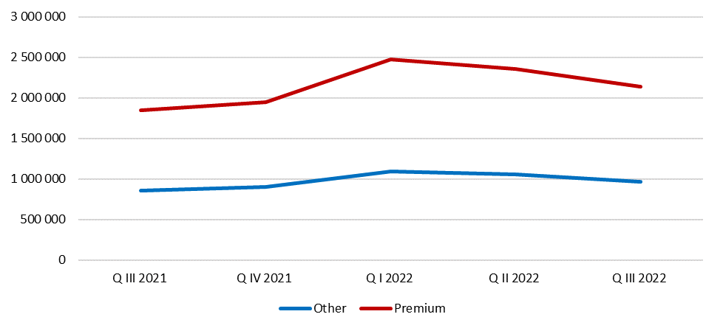
Source: NAPI (National Industrial Information Agency)

Average prices for used cars aged over 10 years, rubles
Price segments | Q III 2021 | Q IV 2021 | Q I 2022 | Q II 2022 | Q III 2022 | Dynamics  Q III 2022/  Q III 2021 | Dynamics  Q III 2022/  Q II 2022
Premium | 782 056 | 896 871 | 1 106 047 | 1 086 796 | 1 107 711 | 41.6% | 1.9%
Other | 404 228 | 440 509 | 512 729 | 521 222 | 513 833 | 27.1% | -1.4%

Source: NAPI (National Industrial Information Agency)
Average prices for used cars aged over 10 years, rubles
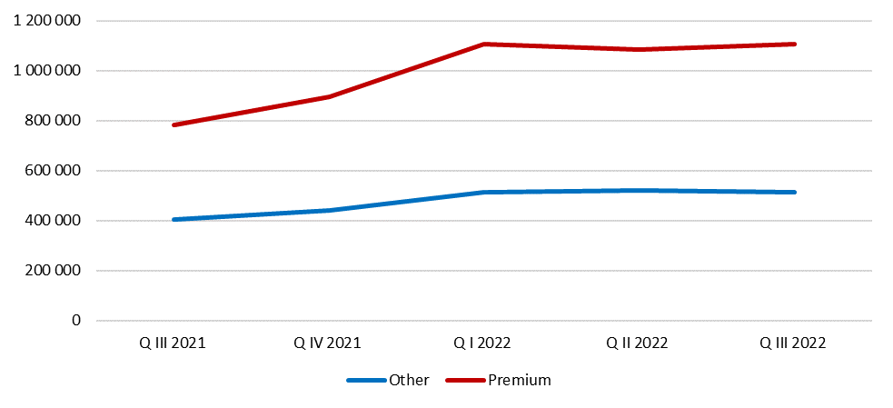
Source: NAPI (National Industrial Information Agency)

