New LCV market forecast
New LCV market forecast is formed taking into account three scripts: basic, optimistic and pessimistic.
According to all forecast scripts, Russian LCV market has been negatively affected by following factors.
1. SANCTIONS
After 24th February 2022 there were economic sanctions imposed against Russian Federation. They affected among other the automotive market. For example, countries which imposed sanctions prohibited the import of microelectronic devices and auto components into Russia.
Sanctions against russian lCV manufacturers
The GAZ group has been included in the USA Finance Ministry sanction list since the 6th of April 2018. Despite that, before the 25th of May 2022 there was an actual postponement allowing to the Group to work with American suppliers and their affirmed mediators according to current contracts. Since the 25th of May this postponement has been cancelled and GAZ lost access to auto components imported directly from the USA and American companies located in other countries.
On the 3rd of June 2022 EU imposed sanctions against UAZ because of their vehicles` exploitation by the Russian Armed Forces. Despite that, UAZ has been working in absence of auto components supplies from European OEM and is consequently realizing the component base replacement program.
In the end of February – beginning of March 2022 because of imposed sanctions AutoVAZ was forced to stop vehicle manufacturing due to delays in auto components supplies. Since the 6th of June 2022 LADA resumed vehicle manufacturing in basic modifications.
Stop of foreign LCVs and auto components manufacturing and import
Since February 2022 Ford, Volkswagen, Toyota, Mitsubishi, Mercedes-Benz etc. have stopped manufacturing on all Russian platforms and suspended news LCV and genuine auto components import. Due to logistic problems with auto components supplies Peugeot and Citroen significantly reduced manufacturing and sales.
2. COVID-19 LOCKDOWNS IN CHINA
The restrictions referred to the COVID-19 pandemic in China in 2022 can lead to delays in auto components` supplies for the Russian platforms such as UAZ, AutoVAZ and others using Chinese components. This will inevitably lead to the decline of Chinese LCV import into Russia. All these factors will provoke new manufacturing outages and growth of vehicle shortage on the Russian market.
3. DECLINE OF RUSSIAN MACROECONOMICS
Sanctions put a negative effect on macroeconomic figures. According to the Central Bank forecasts, Russian GDP can be reduced by 8-10% in 2022.
Inflation level in Russia showed 17,8% in April 2022, according to Federal State Statistics Service. In the end of 2022 Russian Ministry of Economic Development predicts 17,5% inflation.
In 2022 the international transfer is going to be reduced because of the sanctions. The turnover of bulk trade and retail also tends to decrease, which will provoke financial difficulties for road haulers and companies using LCVs for personal needs. In these conditions the LCV corporate fleet renewal will be significantly slowed down.
Autocredits appreciation can also negatively affect the automotive market because of Russian Bank key rate increase in comparison with 2021. At the same time the automotive leasing also appreciated, what reduced vehicle procurements by corporate customers.
The autocredit key rate has been decreased up to 14% since the 14th of May, up to 11% since the 27th of May and up to 9,5% since the 10th of Jone 2022. This will lead to decline of credit and leasing rated in June 2022, however, they will exceed the figures of 2021 (key rate 5 - 5,5%).
4. NEW VEHICLE PRICE GROWTH
In connection with logistic chains` complication, auto components` shortage for LCV manufacturing and increasing inflation, new LCV prices are significantly growing. Considering the financial problems of haulers and other companies consuming LCVs, this will lead to further LCV demand reduction.
5. TCO GROWTH
In 2022 г. prices for spare parts, tires etc. showed a significant increase. TCO growth can negatively affect the decision making about new LCV purchases in 2022.
6. BIG VARIETY ON THE USED LCV MARKET
Last years, a diversified used vehicle fleet was formed in Russia. During the crisis a part of customers prefers used vehicle purchases to the new ones, including «grayly» imported vehicles. Besides that, «fresh» used LCVs can appear on the market because of business reduction of haulers and other companies.
Despite that, here are given the factors allowing to minimize negative tendencies on the new LCV market in 2022.
1. PARALLEL IMPORT LEGALIZATION
On the 6th May 2022, Russian Ministry of Industry and Trade published the list of vehicles and spare parts available for parallel import without right owner`s authorization. The allowed LCV brand list included Volkswagen, Toyota, Mercedes-Benz, Renault, Mitsubishi, Isuzu, Dodge, Chevrolet, Jeep, GMC. The parallel import provides foreign LCVs inflow on the Russian market, however, in connection with logistical complications, supply volumes do not tend to be significant in the current year and will not lead to significant market growth.
2. RUSSIAN AND CHINESE BRANDS CONSERVATION ON THE MARKET
Russian and Chinese brands are planning to conserve their positions on the LCV market. In June 2022 GAZ Group enterprises announced that they will continue working in a full-time week during the year. On the 5th of May the Government of Russian Federation intensified the financial support of GAZ and increased the subsidiary credit limit from 10 to 20 billion rubles.
UAZ continues working according to the standard timetable after a small delay in May. Since the 6th of June AutoVAZ has restarted LADA vehicle manufacturing and will be working in the 4-day working week mode until the 4th of September.
Chinese OEMs are planning to continue LCV supplies into Russia. Despite the logistical problems while transporting vehicles and auto components, these companies are going to stay on the Russian market and to organize sales.
3. State programs restarting
On the 17th of June the head of Russian Ministry of Industry and Trade Denis Manturov declared that beneficial autocredit and autoleasing programs will be restarted according to Russian Government statements № 364 and № 649 correspondently. TCO limit for vehicles included in these programs is going to be increased from 1,5 to 3 million rubles.
Totally, in 2022 Russian Government is planning to subside 20,7 billion rubles for automotive market support. Autocredits will be subsided with 10,2 billion rubles, beneficial leasing – with 4,9 billion rubles, discounts for electric vehicle – with 2,6 billion rubles, gas fuel vehicle procurements – with 3,3 billion rubles.
Basic forecast script supposes that sanction measures against Russia will be conserved up to the end of 2022. GAZ and UAZ will continue LCV sales in «basic» versions. AutoVAZ restarts manufacturing and sales of LADA Largus in the 4th quarter. Chinese brands will be able to establish the logistic chains for vehicle and spare components transport into Russia in the 2nd half of 2022. LCVs, whose supplies into Russia are prohibited, will be parallel imported in small volumes. Russian economy will show a depressed tendency up to the end of 2022, but without dramatic declines.
Optimistic forecast script supposes that sanction measures against Russia will be conserved up to the end of 2022, but will be gradually relented. GAZ and UAZ will continue LCV sales in «basic» versions. AutoVAZ restarts manufacturing and sales of LADA Largus in the 3rd quarter. Chinese brands will be able to establish the logistic chains for vehicle and spare components transport into Russia in the 2nd half of 2022. LCVs, whose supplies into Russia are prohibited, will be parallel imported in small volumes. Russian economy will show a depressed tendency up to the end of 2022, but several macroeconomic figures are going to grow in the second half of the year in comparison with March-April.
Pessimistic forecast script supposes that sanction measures against Russia will be conserved up to the end of 2022 and restricted. GAZ and UAZ will continue LCV sales in «basic» versions, but sales volumes will be decreased. AvtoVAZ does not restart LADA Largus manufacturing and sales. Chinese brands will not be able to establish the logistic chains and will stop vehicle and spare components transport into Russia in the 2nd half of 2022. LCVs, whose supplies into Russia are prohibited, will be parallel imported in insignificant volumes. Russian economy will show a depressed tendency up to the end of 2022, several macroeconomic figures are going to decline in the second half of the year in comparison with March-April.
According to the basic forecast script, new LCV sales will be reduced by 45,68% in 2022 in comparison with 2021 and will show 69,22 thousand. According to the optimistic script, sales decrease will show 41,26%, 74,85 thousand LCVs will be sold. According to the pessimistic script, the sales will be reduced by 50,81% дup to 62,68 thousand.

New LCV market forecast before 2022, thousands
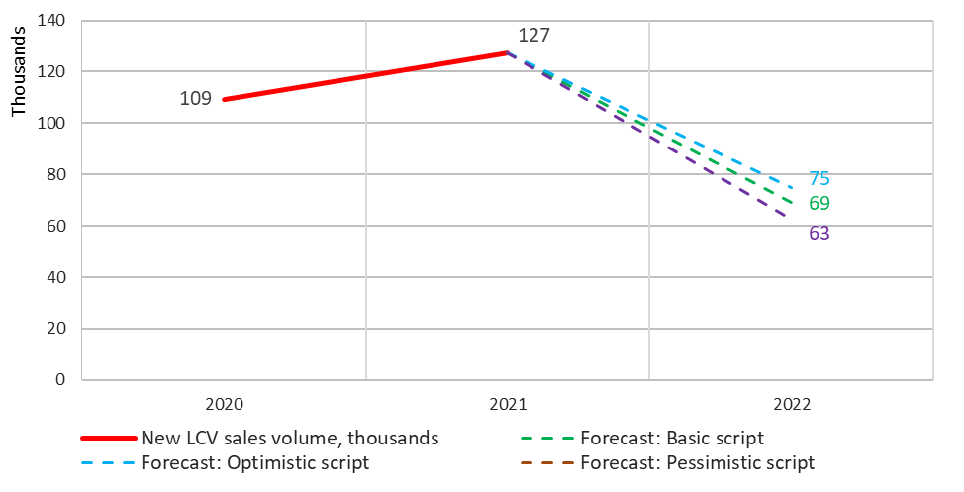
Source: НАПИ/Russian Automotive Market Research

New LCV market structure forecast in 2022
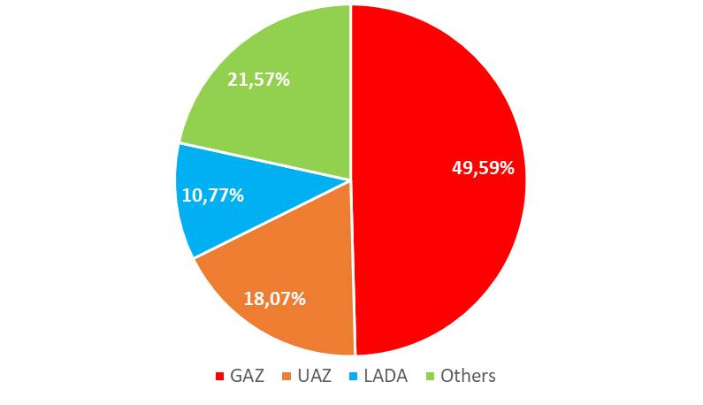
Source: НАПИ/ Russian Automotive Market Research

Here and further: except supplies for Russian Ministry of Defense, security departments.

