Financial leasing of special purpose vehicles
* new and used, excluding automotive special purpose vehicles
Vehicle purpose | Jan-Feb 2024,  thousand units | Jan-Feb 2025,  thousand units | Dynamics
Road construction vehicles | 3.5 | 1.1 | -69.2%
Lifting vehicles | 1.7 | 1.0 | -40.2%
Agricultural vehicles | 1.4 | 0.7 | -50.9%
Warehouse vehicles | 0.2 | 0.1 | -45.5%
Other special purpose vehicles | 0.6 | 0.3 | -56.4%
Total | 7.4 | 3.2 | -57.4%
Source: Federal resource, NAPI (National Industrial Information Agency)
According to the marketing agency NAPI, only 3.2 thousand special purpose vehicles were issued for financial leasing in January-February 2025. Compared to two months of last year, special purpose vehicle leasing fell by 57.4%. In 2023-first half of 2024, vehicles were actively purchased, and by the beginning of this year, the market became saturated. High leasing rates have become a significant obstacle for those wishing to purchase special purpose vehicles.
The road construction vehicle segment suffered particularly. As a result, its share in the special purpose vehicle leasing decreased from 47.4% to 34.3%.
Will the preferential leasing program for municipal and road construction vehicles, launched on April 1, 2025, be able to reverse the trend?
Special purpose vehicle financial leasing composition in January-February 2024
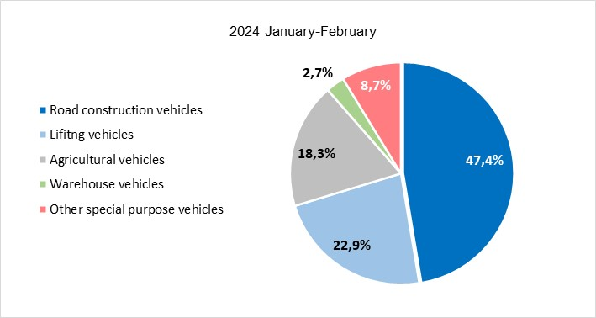
Source: Federal resource, NAPI (National Industrial Information Agency)

Special purpose vehicle financial leasing composition in January-February 2025
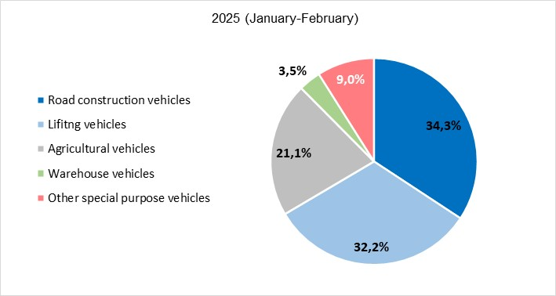
Source: Federal resource, NAPI (National Industrial Information Agency)

