**Financial leasing of special purpose vehicles**

*\* new and used, excluding automotive special purpose vehicles*

|  |  |  |  |
| --- | --- | --- | --- |
| **Vehicle purpose** | **Jan-Feb 2024,  thousand units** | **Jan-Feb 2025,  thousand units** | **Dynamics** |
| Road construction vehicles | 3.5 | 1.1 | -69.2% |
| Lifting vehicles | 1.7 | 1.0 | -40.2% |
| Agricultural vehicles | 1.4 | 0.7 | -50.9% |
| Warehouse vehicles | 0.2 | 0.1 | -45.5% |
| Other special purpose vehicles | 0.6 | 0.3 | -56.4% |
| Total | 7.4 | 3.2 | -57.4% |

*Source: Federal resource, NAPI (National Industrial Information Agency)*

According to the marketing agency NAPI, only 3.2 thousand special purpose vehicles were issued for financial leasing in January-February 2025. Compared to two months of last year, [special purpose vehicle leasing](https://leasingstat.ru/)  fell by 57.4%. In 2023-first half of 2024, vehicles were actively purchased, and by the beginning of this year, the market became saturated. High leasing rates have become a significant obstacle for those wishing to purchase special purpose vehicles.

The [road construction vehicle segment](https://leasingstat.ru/) suffered particularly. As a result, its share in the special purpose vehicle leasing decreased from 47.4% to 34.3%.

Will the preferential leasing program for municipal and road construction vehicles, launched on April 1, 2025, be able to reverse the trend?

**Special purpose vehicle financial leasing composition in January-February 2024**

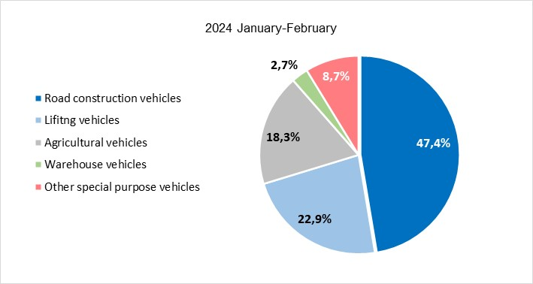

*Source: Federal resource, NAPI (National Industrial Information Agency)*

**Special purpose vehicle financial leasing composition in January-February 2025**

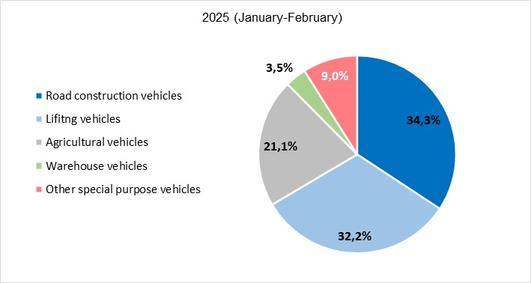

*Source: Federal resource, NAPI (National Industrial Information Agency)*