Car prices fell significantly in January
The marketing agency NAPI analyzed recommended retail prices (RRP) for new cars in January 2024. Compared to December 2023, prices for 35 versions have changed. Prices for a number of CHERY, KAIYI, DONGFENG versions have decreased, a total of 6 versions have become cheaper. Prices for 29 versions increased in January, but not significantly – from 0.3% to 0.7%. The price decline was more significant – from 8.1% to 13.4%.
New car prices, rubles
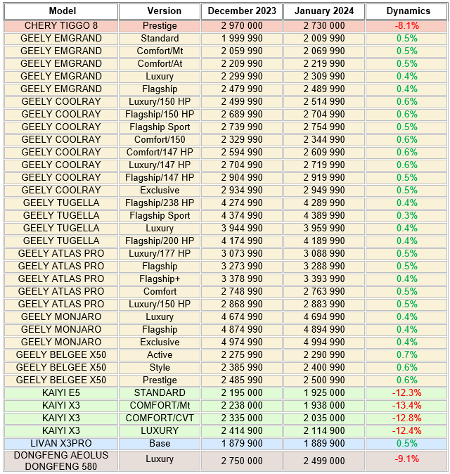
Source: NAPI / National Industrial Information Agency

NAPI / National Industrial Information Agency
www.napinfo.ru
https://leasingstat.ru/
www.dv-tco.ru
Our TELEGRAM channels:
NAPI. Automotive market https://t.me/napinfo
Car total cost of ownership https://t.me/dvtco
Our Yandex.Zen channel https://zen.yandex.ru/id/5ed4f86d0929ca3c20246790
+7 831 439 21 82
+7 831 434 53 94
+7 831 464 02 98

