**CAR LEASING IN 2023**

According to the marketing agency NAPI, in January-February 2023, 19.3 thousand cars were issued for [financial and operational leasing](https://leasingstat.ru/). Compared to the similar period of the last year, car leasing decreased by 49%: so, in January-February 2022, 37.9 thousand cars were leased. The share of operational leasing in the leasing deal structure fell from 5% to 3.8% over the year. The share of new leasing vehicles (financial and operational leasing) in new car sales reached 13% over the first two months of the current year. In the corporate procurement structure, leasing cars accounted for 62.4%.

**Cars in financial leasing, thousand units**

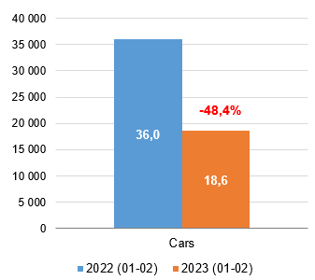

*Source: Federal resource, NAPI / National Industrial Information Agency*

**Cars in operational leasing, thousand units**

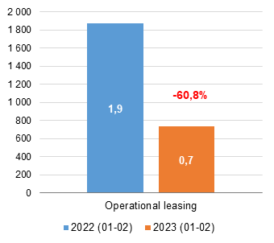

*Source: Federal resource, NAPI / National Industrial Information Agency*

**Car leasing composition**

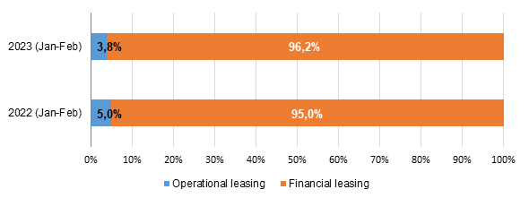

*Source: Federal resource, NAPI / National Industrial Information Agency*

**Leasing in new car sales, thousand units**

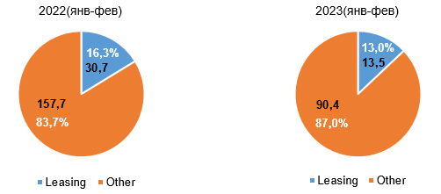

*Source: Federal resource, NAPI / National Industrial Information Agency*

**Leasing in new corporate car sales, thousand units**

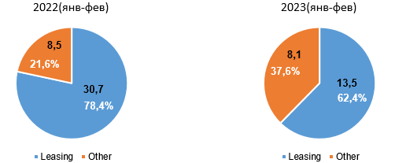

*Source: Federal resource, NAPI / National Industrial Information Agency*

NAPI / National Industrial Information Agency

[www.napinfo.ru](http://www.napinfo.ru)

<https://leasingstat.ru/>

[www.dv-tco.ru](http://www.dv-tco.ru)

Our channels in TELEGRAM:

NAPI. Automotive market <https://t.me/napinfo>

Total cost of vehicle ownership <https://t.me/dvtco>

Our channel in Yandex.Zen <https://zen.yandex.ru/id/5ed4f86d0929ca3c20246790>

+7 831 439 21 82

+7 831 434 53 94

+7 831 464 02 98