Almost the same amount was spent on the purchase of new and used trucks
According to the Marketing Agency NAPI (National Industrial Information Agency), 944.6 billion rubles were spent on the purchase of new and used trucks over eight months of 2022. This amount was almost equally divided between the new and used vehicles, while the share of new vehicles in the sales structure "in quantitative terms" was only 28.4%.
New and used truck market revenue, January-August 2022
 | Sales,  thousand units | Weighted average price, rubles | Market revenue,  million rubes
New vehicles | 53.2 | 8 956 539 | 476 219
Used vehicles | 134.3 | 3 488 065 | 468 423
Total | 187.5 | - | 944 642

Source: NAPI (National Industrial Information Agency)
Truck sales, January-August 2022 | Truck market revenue, January-August 2022
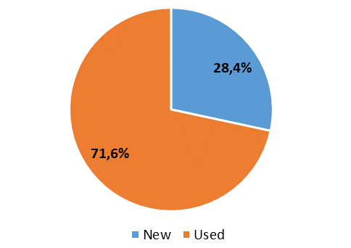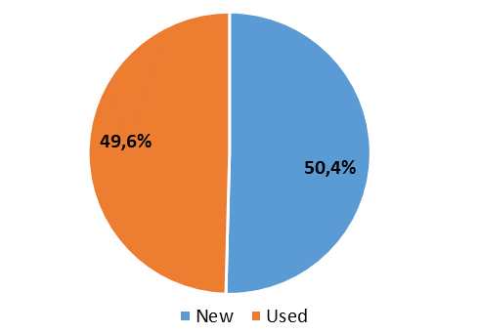
Source: NAPI (National Industrial Information Agency)
New truck sales, thousand units, January-August 2022
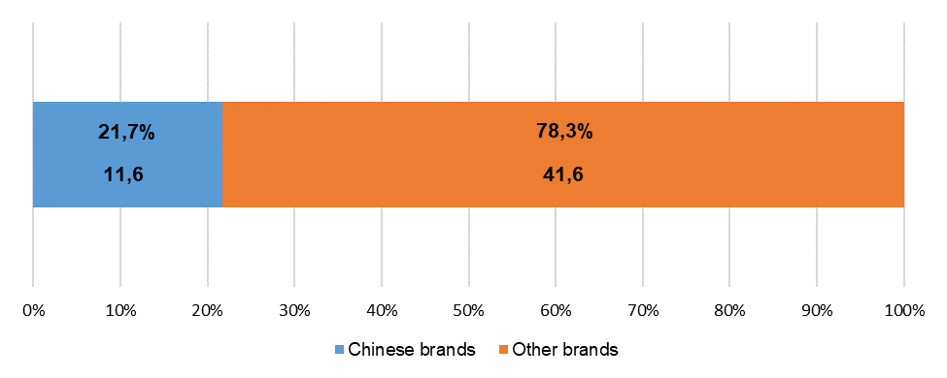
Source: NAPI (National Industrial Information Agency)
New truck market revenue, billion rubles, January-August 2022
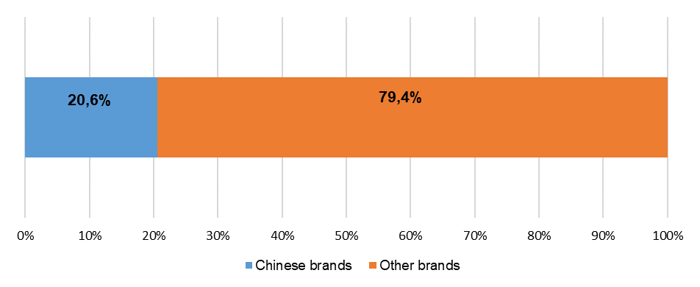
98,2
378
Source: NAPI (National Industrial Information Agency)
Used truck sales, thousand units, January-August 2022
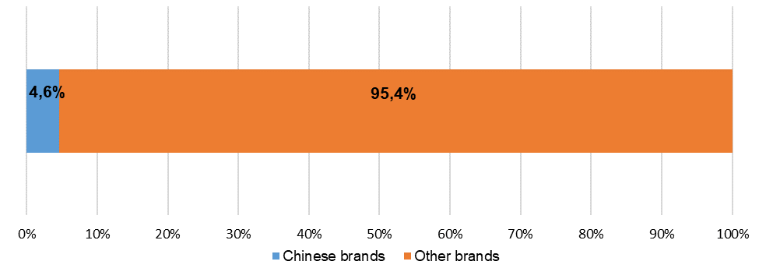
6,3
128,0
Source: NAPI (National Industrial Information Agency)
Used truck market revenue, billion rubles, January-August 2022
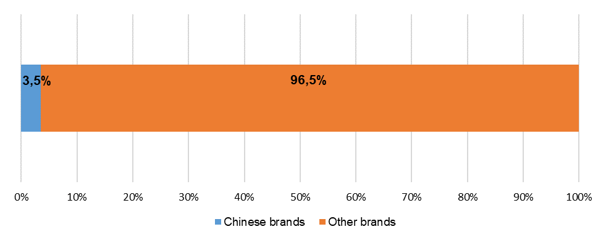
451,8
16,6
Source: NAPI (National Industrial Information Agency)

New truck market revenue, leading Chinese brands, January-August 2022
Brand | Sales,  thousand units | Weighted average price, rubles | Market revenue,  million rubes
SHAANXI | 5 090 | 8 000 515 | 40 723
HOWO | 2 202 | 8 671 705 | 19 095
FAW | 1 669 | 7 514 431 | 12 542
JAC | 1 521 | 6 663 852 | 10 136
SITRAK | 366 | 6 704 400 | 2 454
HONGYAN | 247 | 7 310 276 | 1 806
XCMG | 231 | 22 218 571 | 5 132
ZOOMLION | 171 | 34 841 862 | 5 958

Source: NAPI (National Industrial Information Agency)
Used truck market revenue, leading Chinese brands, January-August 2022
Brand | Sales,  thousand units | Weighted average price, rubles | Market revenue,  million rubes
SHAANXI | 2 151 | 3 071 415 | 6 607
FOTON | 1 413 | 862 614 | 1 219
HOWO | 970 | 2 285 668 | 2 217
FAW | 685 | 3 255 588 | 2 230
DONGFENG | 329 | 1 273 916 | 419
JAC | 209 | 3 893 929 | 814
CAMC | 149 | 1 419 146 | 211
XCMG | 135 | 15 147 898 | 2 045

Source: NAPI (National Industrial Information Agency)

