133.9 BILLION RUBLES WERE SPENT ON THE PURCHASE OF NEW AND USED TRAILERS
According to the Marketing Agency NAPI (National Industrial Information Agency), 133.9 billion rubles were spent on the purchase of new and used trailers over eight months of 2022. The new trailers accounted for 42.4% of this amount, while their share in the sales structure "in quantitative terms" was slightly more than a third. TONAR is a leader in the new trailer market by financial indicators, SCHMITZ is a leader in the used trailer market.
New and used trailer market revenue, January-August 2022
 | Sales,  thousand units | Weighted average price, rubles | Market revenue,  million rubes
New trailers | 22.4 | 2 536 595 | 56 731
Used trailers | 43.0 | 1 793 547 | 77 185
Total | 65.4 | - | 133 916

Source: NAPI (National Industrial Information Agency)
Trailer sales,  January-August 2022 | Trailer market revenue,  January-August 2022
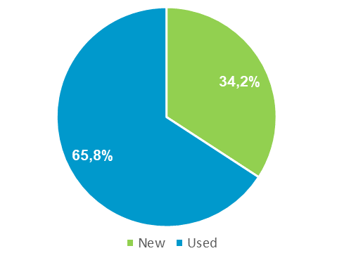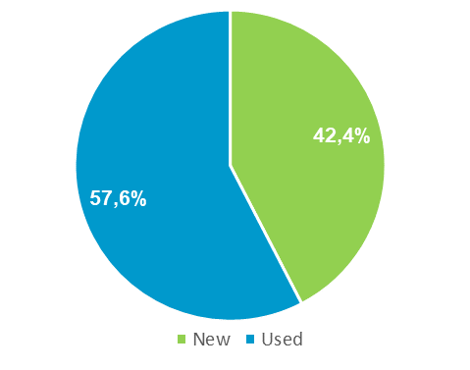
Source: NAPI (National Industrial Information Agency)
New trailer market revenue, ТОР-10 brands, January-August 2022
Brand | Sales,  thousand units | Weighted average price, rubles | Market revenue,  million rubes
TONAR | 3 487 | 2 915 743 | 10 167
SCHMITZ | 1 794 | 4 448 676 | 7 981
KRONE | 847 | 4 274 041 | 3 620
GRUNWALD | 772 | 3 820 652 | 2 950
CENTRTRANSTECHMASH | 779 | 3 504 695 | 2 730
ChMZAP | 784 | 3 376 432 | 2 647
KAESSBOHRER | 665 | 3 929 274 | 2 613
NEFAZ | 1 126 | 1 969 693 | 2 218
BONUM | 676 | 3 137 963 | 2 121
WIELTON | 504 | 4 093 108 | 2 063
Source: NAPI (National Industrial Information Agency)
Sales and market revenue, 2022 (January-August)
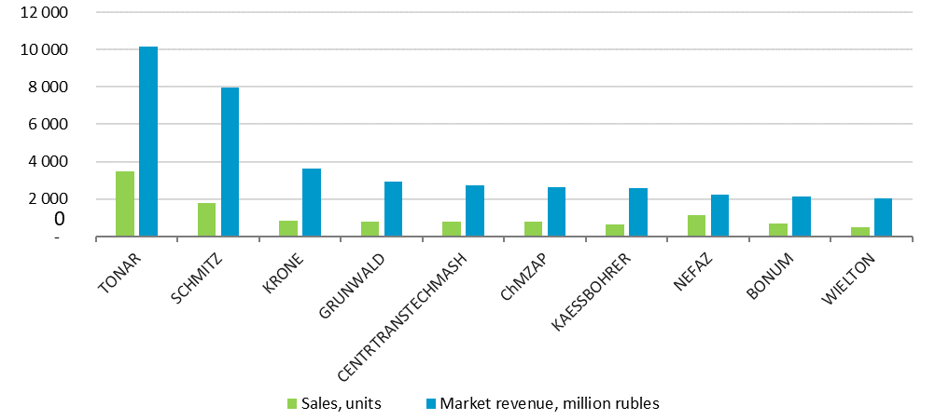
Source: NAPI (National Industrial Information Agency)
Used trailer market revenue, ТОР-10 brands, January-August 2022
Brand | Sales,  thousand units | Weighted average price, rubles | Market revenue,  million rubes
SCHMITZ | 7 601 | 2 470 130 | 18 775
KRONE | 4 789 | 1 891 763 | 9 060
GRUNWALD | 1 297 | 2 819 884 | 3 657
TONAR | 2 217 | 1 570 764 | 3 482
KOEGEL | 2 013 | 1 578 855 | 3 178
WIELTON | 882 | 2 336 686 | 2 061
SZAP | 2 590 | 745 780 | 1 932
NEFAZ | 2 130 | 866 146 | 1 845
KAESSBOHRER | 606 | 2 716 952 | 1 646
SESPEL | 803 | 1 848 071 | 1 484
Source: NAPI (National Industrial Information Agency)
Sales and market revenue, 2022 (January-August)
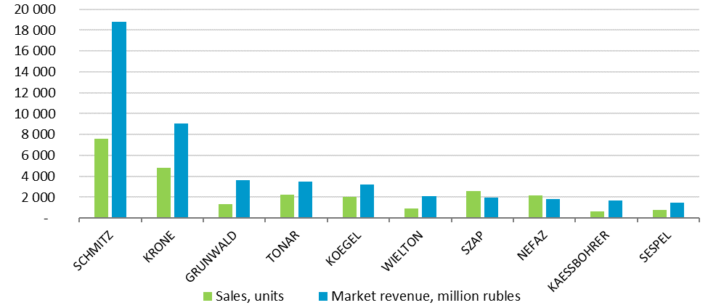
0
Source: NAPI (National Industrial Information Agency)

